Exploratory and Predictive Analytics of Global Restaurant Markets with Zomato Price–Rating Data Using Ensemble Regression Models

K.Thirumalvalavan
Department of Management Studies
SRM Arts and Science College, Kattankulathur, Chennai, India
thirumalvalavankmba@srmasc.ac.in
Jeyasree A
Department of MBA
Dhanalakshmi Srinivasan College of Engineering and Technology
Chennai, Tamil Nadu, India
jsridoss1196@gmail.com
B.T.Geetha
Department of EEE
Saveetha School of Engineering, SIMATS, Saveetha University
Chennai, Tamil Nadu, India
dr.geetha.bt@gmail.com
G Sangeetha
Department of Commerce
SRM Institute of Science and Technology,
Kattankulathur, Chennai, India
sysubhi209@gmail.com
Saravanan J
Department of CSE
Dhanalakshmi Srinivasan College of Engineering and Technology
Chennai, Tamil Nadu, India
saravanan12220@gmail.com
Geetha M
Department of IT
S.A. Engineering College (Autonomous)
Chennai, Tamil Nadu, India
geethachenbapan@gmail.com

Abstract— Online food platforms have made it possible to observe how pricing, customer engagement, and service features influence restaurant performance at a global scale. This research work analyses these relationships using a multi-country Zomato dataset, with the goal of predicting restaurant ratings from economic and service-related attributes. To ensure comparability across regions, all currency values were converted into a common currency as USD and additional indicators, such as cuisine variety and availability of online services, were derived from the raw Kaggle dataset and a total of 7,403 restaurants were analyzed using five regression approaches (Linear Regression, Extra Trees Regressor, Multilayer Perceptron (MLP), HistGradient Boosting (HGB), and a stacked ensemble model). The results show that ensemble-based models significantly outperform linear baselines, the stacked ensemble achieving the best performance (R² = 57.03%, RMSE = 0.3645, MAE = 0.2712). Furthermore, a dashboard has been developed on both sides for prediction. And the remaining analysis indicates that customer voting activity and pricing structure play a dominant role in shaping ratings, while service options such as table booking and online delivery have a smaller but measurable effect. These findings highlight the value of ensemble learning for understanding and forecasting restaurant quality on large-scale food-service platforms.
Keywords— Zomato dataset, Restaurant analytics, Ensemble learning, Regression models, Global food markets, HistGradient Boosting (HGB), Multilayer Perceptron (MLP), customer behavior modeling.

Introduction
Historically, finding a good and the best place to eat was a matter of trying it out or following someone else’s recommendations. Digital food platforms have transformed the way customers select dining options and how restaurants compete in a crowded marketplace. Services such as Zomato, Swiggy collect extensive data on pricing, customer ratings, service attributes, and user engagement, enabling detailed analysis of restaurant performance and customer satisfaction. Understanding the relationships among pricing strategies, service availability, and customer ratings is essential for restaurants aiming to optimize their operations and for platforms seeking to enhance recommendation systems globally.
Customer ratings on online platforms reflect complex interactions among restaurant attributes and user perception. Machine learning–based or deep learning based predictive models have been used to forecast restaurant ratings using regression and classification methods. Prior research has compared linear regression and decision tree models for predicting restaurant ratings, showing that nonlinear models often outperform simple linear methods [1]. The authors [2] aim to predict restaurant ratings on Yelp using data collected in 2018, which comprises over 200,000 businesses and 7 million reviews, necessitating substantial preprocessing and yielding valuable insights for consumers and investors regarding future restaurant performance. Yelp ratings are crucial indicators of restaurant quality and service, with higher ratings significantly enhancing customer attraction. The research was done for five machine learning models, including regression, Naive Bayes, Decision Tree, and Neural Network, achieving a maximum prediction accuracy of 82.50%. The analysis includes both text-based features, such as unigrams and bigrams from reviews, and non-text features, such as review counts, underscoring the importance of feature engineering in understanding the factors influencing restaurant ratings.
A few years ago, finding a great restaurant completely relied on word-of-mouth or travel guides, which were more trusted methods but subjective and very slow. As industries moved online, researchers turned to basic statistical methods, such as linear regression, to analyse the new “Electronic Word-of-Mouth” strategy [3]. These basic models treated dining as a simple mathematical equation and assumed that a straight line with higher prices, or the presence of a specific keyword, automatically indicated better ratings [4].
However, these straight-line models fail to capture the messiness or noise of the real world and struggle with global standardisation, unable to normalise how a budget meal in India compares to a luxury dinner in New York. They treat the features as independent variables, overlooking the complexity and nonlinear human behaviours, such as the convenience of online delivery, that help define the restaurant’s success [5].
The review of recent literature identifies two critical voids that this proposed model specifically addresses. Most of the existing research only focuses on isolated regions and analyses a single city, like Bangalore, London, or a specific country. These models rarely attempt to harmonise the data across borders, so the previous models fail to account for the Purchasing Power Parity (PPP) differences between nations, making it impossible to compare a budget meal in India with a budget meal in the US accurately [6]. While the new research has moved away from the simple Linear Regression, the majority of the studies still rely on the standalone algorithms like Random Forest or Support Vector Machine (SVM) [7]. Few researchers have used the Meta-Learning model (Stacked Ensemble) in the service sectors. The previous works missed the opportunity to combine the logic of different algorithms to minimize the error variance. Ensemble and deep learning models have been applied to a wide range of real-world prediction problems, including socioeconomic forecasting and market-level economic growth behavior modelling [18], [19]. Beyond commercial value, data-driven restaurant analytics also support the United Nations Sustainable Development Goals (SDGs), particularly SDG 8 (Decent Work and Economic Growth) and SDG 12 (Responsible Consumption and Production). By improving business sustainability and enabling consumers to make informed dining choices, predictive analytics contributes to economic resilience and resource-efficient consumption.

Zomato Dataset and Predictive Analytics Methodology
The research was conducted using a global restaurant dataset from Zomato, obtained from the Kaggle platform [8], which provides detailed information on restaurants operating across multiple countries. Each record in the dataset represents a single restaurant and includes attributes such as location, pricing, cuisines served, customer votes, service availability (online delivery and table booking), and an aggregate customer rating. After removing entries with missing or zero ratings and incomplete records, a total of 7,403 restaurants were retained for further analysis.
To enable reliable global analysis, several preprocessing steps were applied. First, restaurants with zero or undefined ratings were removed, as they do not provide meaningful training signals for predictive models. Missing values in categorical fields, such as cuisine type, were imputed with a neutral category to maintain data completeness. Since the dataset comprises restaurants from different countries and uses different currencies, all cost-related attributes were converted to a common currency. The “average cost for two” variable was converted to United States Dollars (USD) using predefined exchange rates. This normalization allows the learning models to interpret price information consistently across geographic regions. Binary service attributes, such as online delivery and table booking, were encoded numerically. In addition, a new feature called cuisine count was derived by counting the number of cuisines offered by each restaurant, providing a quantitative measure of menu diversity.
Six key features were selected for prediction: average cost in USD, price range, number of customer votes, availability of table booking, availability of online delivery, and number of cuisines. These variables capture economic, popularity, and service-quality aspects of restaurant performance. Before training the models, all numerical features were standardised using z-score normalisation. Feature scaling ensures that variables measured on different scales contribute equally to learning, which is particularly important for neural networks and distance-based algorithms.
Figure 1 illustrates the proposed hierarchical framework for global restaurant analytics and rating prediction. The architecture comprises five sequential phases, beginning with data acquisition and culminating in user-level deployment via a decision-support dashboard. In Phase 1, restaurant data is collected from the Kaggle-hosted global Zomato dataset and standardized through currency conversion to USD for all currencies and cleaning. All local currencies are converted to a unified USD format, and incomplete records and invalid ratings are removed to ensure data consistency. Binary service attributes, such as online delivery and table booking, are also encoded at this stage.
Phase 2 focuses on feature engineering and preprocessing. Quantitative features such as average cost, price range, and number of votes are normalized to prevent scale dominance, while new attributes, including cuisine count, are derived to represent menu diversity. The aggregate restaurant rating is selected as the target variable for regression-based prediction. In Phase 3, a hierarchical ensemble learning structure is employed. Base learners, including Linear Regression, Extra Trees Regressor, Multilayer Perceptron, and HistGradient Boosting, are trained independently to capture different types of relationships within the data. Their outputs are then integrated by a stacked ensemble meta-learner, which produces the final prediction. This layered design enables the system to leverage both linear trends and complex non-linear interactions.
Phase 4 implements dual-mode deployment. In the business intelligence mode, the model supports predictive simulations that allow investors and analysts to estimate restaurant performance under different pricing and service conditions. In the customer discovery mode, intelligent filtering and ranking are applied to identify restaurants that best match user preferences based on location, budget, and predicted quality. Finally, Phase 5 presents the results via an interactive dashboard built with Streamlit and Hugging Face Spaces. This interface provides real-time access to prediction results, restaurant rankings, and market insights, enabling both businesses and consumers to benefit from the proposed predictive analytics framework.
A linear regression model [9] was first used as a baseline to capture simple linear relationships between the features and ratings. To model more complex and non-linear patterns, an Extra Trees Regressor [10] was employed, which uses an ensemble of randomized decision trees to reduce variance and improve robustness. A Multilayer Perceptron (MLP) neural network [11] was also trained to capture highly non-linear dependencies among features. In addition, a HistGradient Boosting (HGB) model [12] was used due to its ability to efficiently learn non-linear feature interactions and handle large datasets. Finally, a stacked ensemble model was constructed by combining the Extra Trees, MLP, and HGB models. The outputs of these base learners were integrated by a linear meta-learner, enabling the ensemble to leverage the strengths of each individual model.
The dataset was divided into training and testing sets using an 80:20 split. All models were trained on the training set and evaluated on unseen test data. Performance was measured using three standard regression metrics: Mean Absolute Error (MAE), Root Mean Squared Error (RMSE), and the coefficient of determination (R²). These metrics provide complementary views of prediction accuracy and model reliability. This methodological framework enables a comprehensive comparison of traditional, ensemble, and deep learning approaches for predicting restaurant ratings in a global food service environment. All experiments were conducted in the Google Colab cloud-based Python environment [13]. Figure 2 presents the deployed interactive dashboard developed for the proposed ensemble-based rating prediction framework.

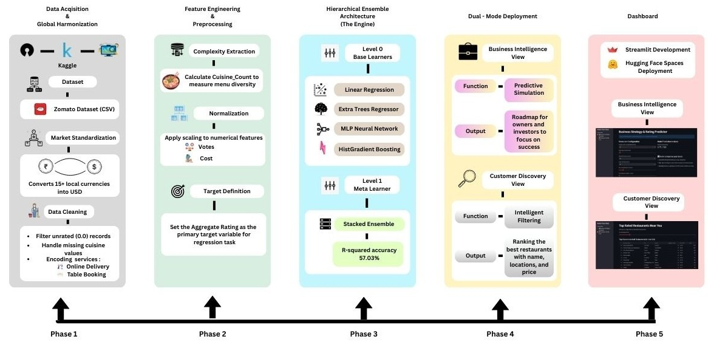
Fig. 1. Hierarchical framework for global restaurant analytics and dual-mode predictive deployment.

The platform operates in two modes: Business Strategy & Simulation and Customer Discovery. In business mode, users can adjust restaurant attributes, such as price, number of votes, cuisine variety, and service availability, to obtain real-time predicted ratings and recommendations for improvement. In the customer mode, users specify their budget to receive a ranked list of top-rated restaurants filtered by price and location. This dual-mode design enables both strategic planning for businesses and intelligent restaurant selection for customers within a single unified system. The use of a globally harmonised digital food-service dataset aligns with SDG 9 (Industry, Innovation, and Infrastructure) by demonstrating how artificial intelligence and cloud-based analytics can strengthen digital service ecosystems in both emerging and developed markets.

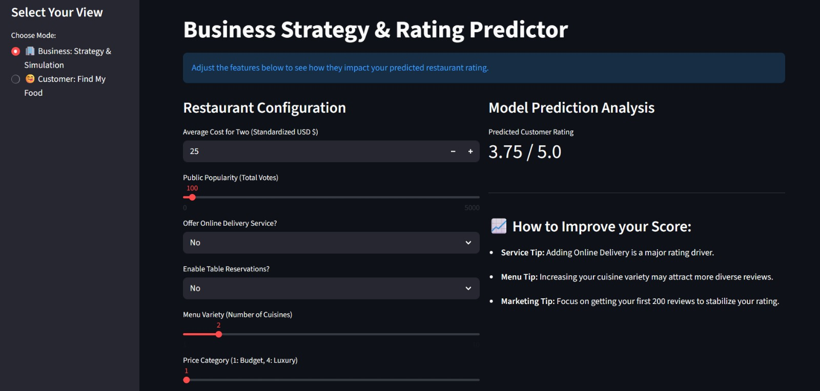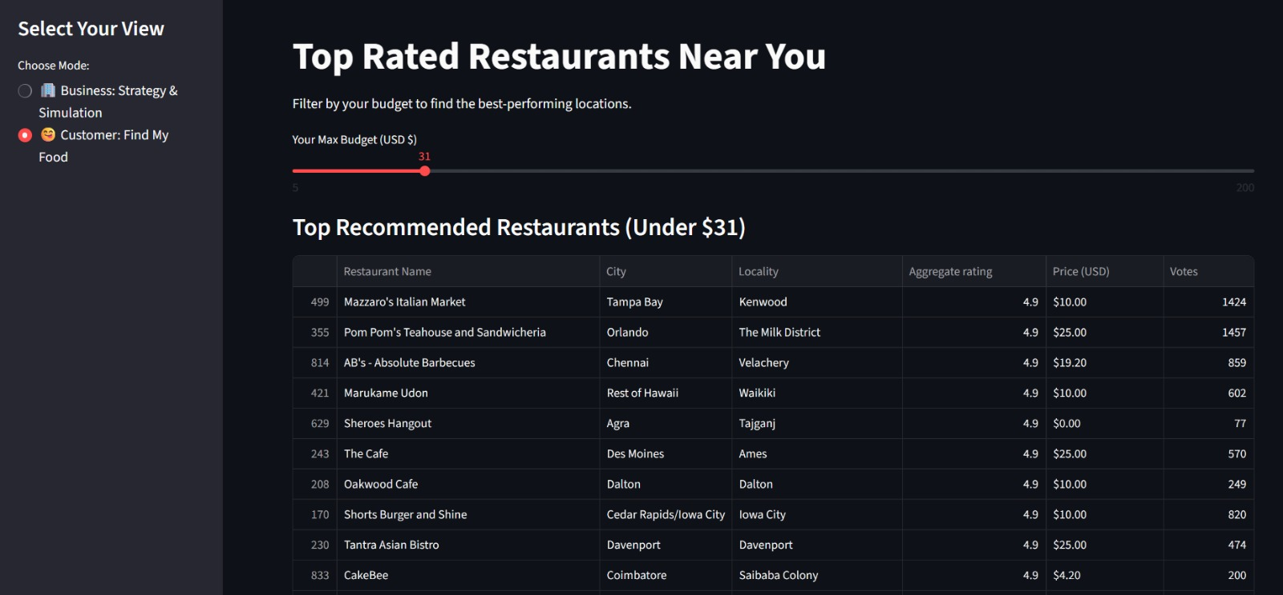
Fig 2. Circuit and 3D view Heatmap of Total Renewable Energy Production by Country and Year

Evaluation metrics and results
To quantitatively measure the prediction accuracy of the proposed models, three standard regression metrics were employed. Mean Absolute Error (MAE) measures the average absolute difference between the predicted and actual restaurant ratings. It indicates the average number of rating points by which the prediction deviates from the actual value. Root Mean Squared Error (RMSE) penalizes larger errors more strongly by squaring the residuals before averaging. This metric is sensitive to outliers and provides insight into how well the model handles complex cases. The coefficient of Determination (R²) represents the proportion of variance in restaurant ratings explained by the model. Higher R² values indicate stronger predictive capability and better model fit. Together, these three metrics provide a comprehensive view of both the accuracy and robustness of each learning method. Five regression models were trained and tested on the standardized Zomato dataset. Table I summarizes their predictive performance. Fig. 3 shows the Comparison of R² (coefficient of determination) across all prediction models. Fig. 4 show the Actual versus predicted restaurant ratings using the stacked ensemble model. Fig. 5 shows the Actual versus predicted restaurant ratings and residual analysis using the linear regression baseline model.
- Comparion of Five regression models for predictive analysis
Model | MAE | RMSE | R² (%)
Linear Regression | 0.3665 | 0.4635 | 30.54
Extra Trees Regressor | 0.3105 | 0.4192 | 43.18
MLP Neural Network | 0.2844 | 0.3773 | 53.98
HistGradient Boosting | 0.2729 | 0.3660 | 56.69
Stacked Ensemble | 0.2712 | 0.3645 | 57.03

The linear regression baseline achieves the lowest accuracy, explaining only about 30% of the variance in restaurant ratings. This confirms that rating behavior is highly non-linear and cannot be adequately modeled by simple linear relationships. Tree-based and neural network models provide substantial improvements. The Extra Trees Regressor increases the explained variance to over 43%, while the MLP neural network captures more complex feature interactions, achieving nearly 54% accuracy. The HistGradient Boosting model further improves performance by learning non-linear feature interactions more efficiently, reaching an R² of 56.69%. The highest accuracy is achieved by the stacked ensemble, which combines the strengths of the Extra Trees, MLP, and HGB models, yielding an R² of 57.03% and the lowest MAE.
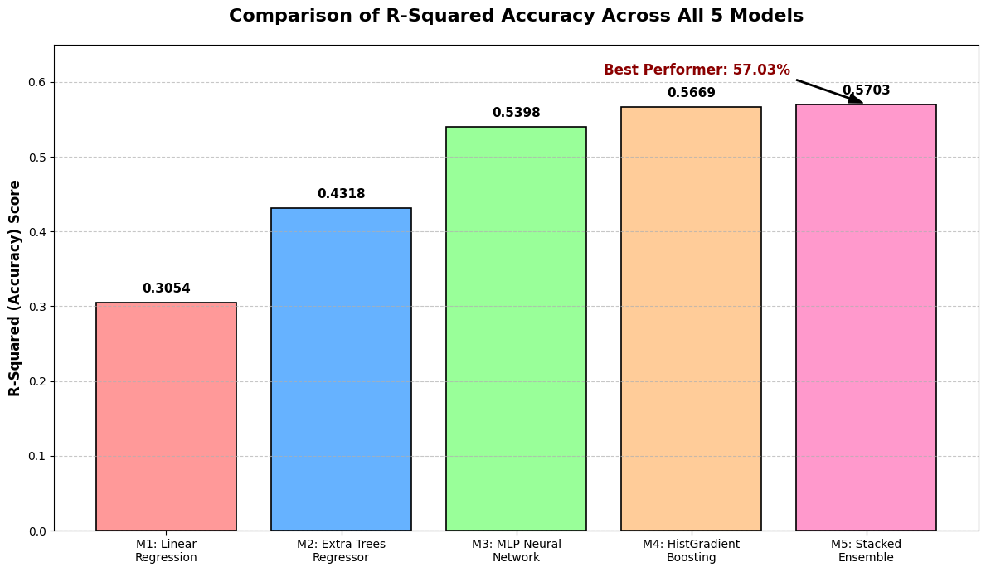
Fig. 3. Comparison of R² (coefficient of determination) across all prediction models.
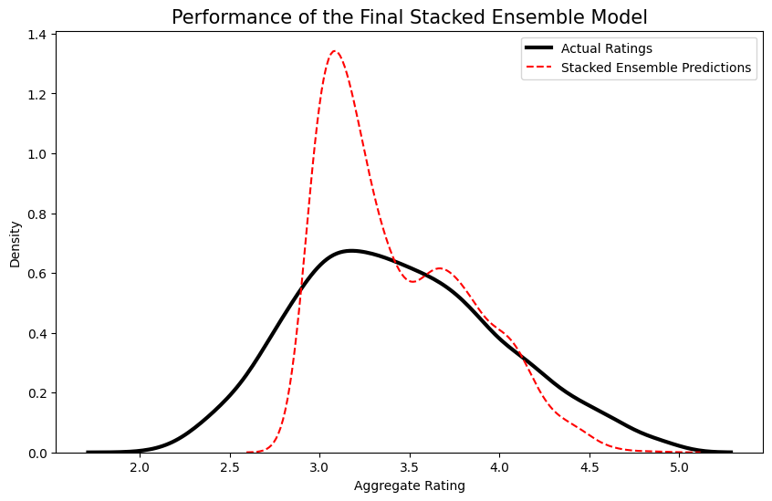
Fig. 4. Actual versus predicted restaurant ratings using the stacked ensemble model.

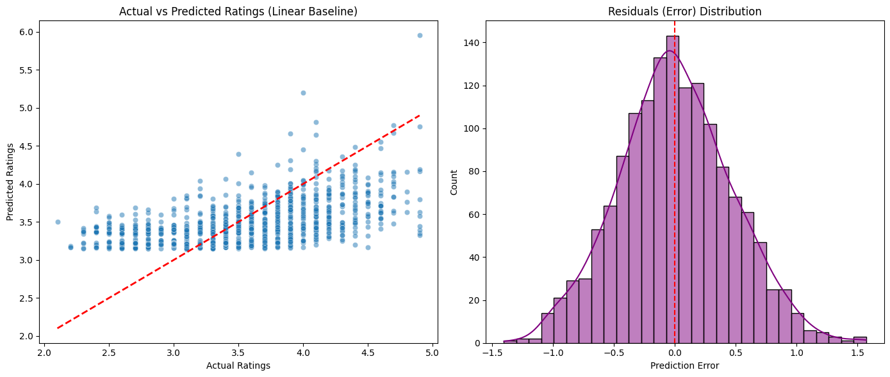
Fig. 5. Actual vs Predicted Plot and Residual Analysis for Linear Regression
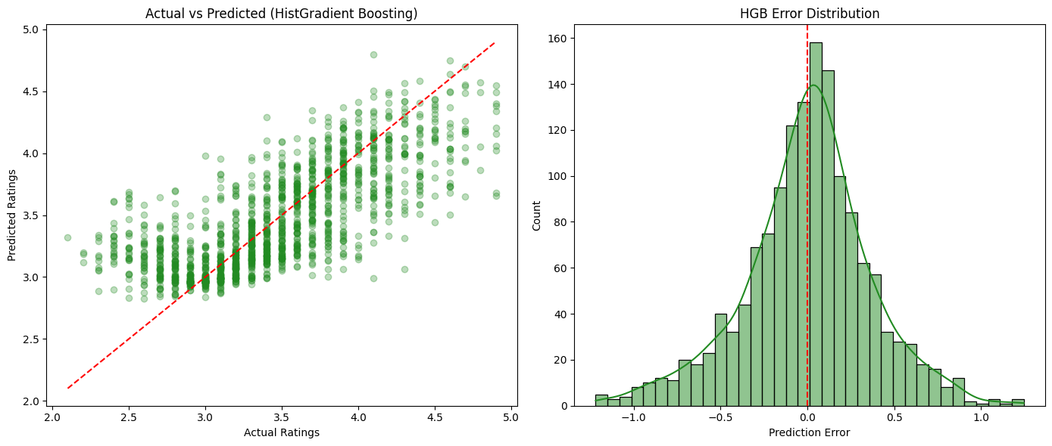
Fig. 6. Actual vs Predicted Plot and Residual Analysis for HistGradient Boosting

Figure 6 shows that this model handles outliers (unusual data) very well and keeps predicted ratings very close to actual Zomato scores. The symmetrical error distribution confirms that the model is fair and does not consistently over- or underestimate. The final results demonstrate the working and pros of the Stacked Ensemble over traditional standalone methods. While the Linear Baseline struggled with global data noise (30.5% accuracy), the Stacked Ensemble captured nonlinear market behaviour, improving accuracy to 57.03%. The methodology represents the justification for applying a Unified USD Baseline. Unlike previous studies that relied on a single city, such as Bangalore [14], the proposed model harmonised data from 141 cities. To overcome local market limitations, this standardised approach was used to demonstrate that ensemble methods provide greater stability across diverse economic regions than region-specific algorithms. Unlike traditional beliefs focused on food taste, the proposed model reveals that votes and online delivery are the strongest predictors. This feature works like a bridge to the e-WOM theory, suggesting that digital engagement is now as critical as food quality [15][16]. In such situations, the Dual-Mode Dashboard is used to simulate rating outcomes based on service upgrades, thereby reducing business risk. The proposed system currently relies on quantitative data and does not perform NLP-based text analysis of reviews. Secondly, the system does not account for offline marketing factors, which means the evaluation scores are expected to differ in contexts with low digital adoption.

Conclusion
This research carried out an ensemble-based predictive analytics framework for modeling restaurant ratings using the global Zomato dataset taken from Kaggle. By integrating linear regression, Extra Trees, Multilayer Perceptron, and HistGradient Boosting models into a stacked learning ensemble architecture, we effectively captured both linear and nonlinear relationships among restaurant attributes. Experimental results demonstrated that the stacked ensemble achieved the highest accuracy and outperformed individual models in terms of MAE, RMSE, and R². A dual-mode interactive dashboard that supports both business-level strategy simulation and customer-centric restaurant discovery, which has been created for offline purposes. This end-to-end approach bridges the research gap between machine learning research and real-world decision support, enabling customers and admins to explore how pricing, service availability, and customer engagement influence perceived restaurant quality. The framework further contributes to the Sustainable Development Goals through digital food ecosystems by supporting informed business planning, efficient resource utilization, and responsible consumer choice (SDG-8, SDG-9, and SDG-12). This predictive framework can be further expanded in future to include revenue forecasting, demand prediction, and restaurant survival analysis, providing deeper insights for investors and policymakers.

References
- T. D. Sarkar, M. S. Rahman and M. Y. Emon, "Predicting Restaurant Ratings: A Comparative Study of Linear Regression and Decision Tree Regression Models in Machine Learning Technology," 2024 4th International Conference on Advancement in Electronics & Communication Engineering (AECE), GHAZIABAD, India, 2024, pp. 481-486, doi: 10.1109/AECE62803.2024.10911460.
- Y. Chen and F. Xia, "Restaurants’ Rating Prediction Using Yelp Dataset," 2020 IEEE International Conference on Advances in Electrical Engineering and Computer Applications( AEECA), Dalian, China, 2020, pp. 113-117, doi: 10.1109/AEECA49918.2020.9213704.
- T. Hennig-Thurau, K. P. Gwinner, G. Walsh, and D. D. Gremler, "Electronic word-of-mouth via consumer-opinion platforms: What motivates consumers to articulate themselves on the Internet?," Journal of Interactive Marketing, vol. 18, no. 1, pp. 38-52, 2004. doi: 10.1002/dir.10073.
- Q. Ye, R. Law, B. Gu, and W. Chen, “The influence of user-generated content on traveler behavior: An empirical investigation on the effects of e-word-of-mouth to hotel online bookings,” Computers in Human Behavior, vol. 27, no. 2, pp. 634-639, Mar. 2011. doi: 10.1016/j.chb.2010.04.014.
- Z. Zhang, Q. Ye, R. Law, and Y. Li, “The impact of e-word-of-mouth on the online popularity of restaurants: A comparison of consumer reviews and editor reviews,” International Journal of Hospitality Management, vol. 29, no. 4, pp. 694-700, Dec. 2010. doi: 10.1016/j.ijhm.2010.02.002.
- D. S. Prasada Rao and G. Hajargasht, "Stochastic approach to computation of purchasing power parities in the International Comparison Program (ICP)," Journal of Econometrics, vol. 191, no. 2, pp. 414-425, Apr. 2016, doi: 10.1016/j.jeconom.2015.12.012.
- J. Priya, "Predicting Restaurant Rating using Machine Learning and comparison of Regression Models," 2020 International Conference on Emerging Trends in Information Technology and Engineering (ic-ETITE), Vellore, India, 2020, pp. 1-5, doi: 10.1109/ic-ETITE47903.2020.238.
- Kaggle Dataset, URL: https://www.kaggle.com/datasets/harishkumardatalab/global-zomato-dataset, Accessed: Jan 09, 2026.
- J. Groß, “The linear regression model. In: Linear Regression, Lecture Notes in Statistics, vol. 175. Berlin, Germany: Springer, 2003, pp. 7–36, doi: 10.1007/978-3-642-55864-1_2.
- P. Geurts, D. Ernst, and L. Wehenkel, “Extremely randomized trees,” Machine Learning, vol. 63, no. 1, pp. 3–42, Mar. 2006. https://doi.org/10.1007/s10994-006-6226-1.
- Marius-Constantin Popescu, Valentina E. Balas, Liliana Perescu-Popescu, and Nikos Mastorakis, “Multilayer perceptron and neural networks”, WSEAS Trans. Cir. and Sys. Volume 8, Issue 7, July 2009, 579–588.
- A. Guryanov, "Histogram-based algorithm for building gradient boosting ensembles of piecewise linear decision trees," in Analysis of Images, Social Networks and Texts (AIST 2019), W. M. P. van der Aalst et al., Eds. Cham, Switzerland: Springer, 2019, pp. 39–50, doi: 10.1007/978-3-030-37334-4_4.
- Google, "Google Colaboratory," URL: https://colab.research.google.com/, Accessed: Jan 09, 2026.
- M. A. Rahman, M. R. Islam, and M. M. Hasan, “Ensemble deep learning: A review,” Engineering Applications of Artificial Intelligence, vol. 115, Art. no. 105151, Oct. 2022.
- S. Bhatia, C. Arya, S. Verma, D. Gautam, B. B. Naib and A. Kumar, "Predict Success of a Zomato Restaurant using Machine Learning," 2023 World Conference on Communication & Computing (WCONF), RAIPUR, India, 2023, pp. 1-7, doi: 10.1109/WCONF58270.2023.10235064.
- Y. Albalawi, J. Buckley, and N. S. Nikolov, “Investigating the impact of pre-processing techniques and pre-trained word embeddings in detecting Arabic health information on social media,” Journal of Big Data, vol. 8, no. 1, Art. no. 95, Jul. 2021.
- M. H. K. Mehedi et al., “Deep hierarchical networks for sentiment analysis of restaurant reviews from food apps,” Scientific Reports, vol. 15, no. 1, Art. no. 40148, Nov. 2025.
- S. Narendran, "Enhanced Prediction of Happiness Scores Using Explainable AI and Ensemble Models with Socioeconomic Data," 2024 IEEE 16th International Conference on Computational Intelligence and Communication Networks (CICN), Indore, India, 2024, pp. 1429-1434, doi: 10.1109/CICN63059.2024.10847491.
- S. Narendran, "Evaluating Traditional and Advanced Forecasting Models for Economic Impact Prediction in Agriculture A Machine Learning Approach," 2024 International Conference on Emerging Technologies and Innovation for Sustainability (EmergIN), Greater Noida, India, 2024, pp. 607-612, doi: 10.1109/EmergIN63207.2024.10961749.

